Ray W. Johnson
October 21, 1933 - July 1, 2024
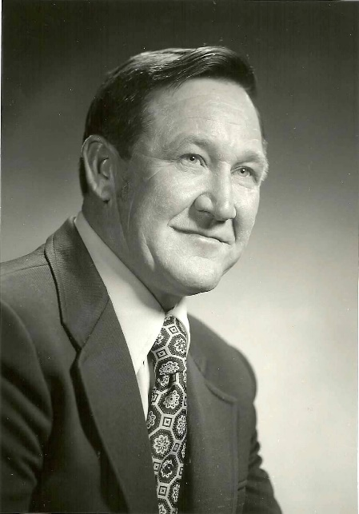
Ray W. Johnson, 90, died in his sleep July 1, 2024, at Oakwood Village Prairie Ridge Assisted Living in Madison, WI. He was born Oct. 21, 1933, on the family farm near Durand, IL, to Mary (Ericson) and Frank N. Johnson, the youngest of four sons.
A 1951 Durand High School graduate, Ray was active in FFA and awarded District 1 State Star Farmer. He attended Northern Illinois University in DeKalb, IL. Ray married Frances Eickstead on June 12, 1955, at the Unitarian church in Rockford, IL. While serving in the U.S. Army from 1956-58, the couple lived in New Jersey and Alabama. Ray and Frances returned to Durand in 1958 and started Johnson Angus Farm with his brother, Glen (Putter). Ray and Frances purchased a farmstead the following year near Brodhead, WI, where they lived for 55 years.
Known as an innovator in agriculture, especially the Angus business, Ray held several leadership roles, including board chair of the Wisconsin State Fair Park Board, president of the Wisconsin National Farmers Organization, and director of the Wisconsin Angus Association, and the Northern Illinois Angus Association. He served on the agricultural advisory committee to U.S. Rep. Les Aspin. Ray was honored as the Outstanding Young Farmer by the Brodhead Jaycees in 1962 and as a Master Agriculturist by Wisconsin Agriculturist magazine in 1982.
A farm boy with a soft spot for his Queensland Blue Heeler dogs and farm cats, Ray focused on strong genetics to advance the Angus breed and had generations of pedigrees memorized for his herd, which at its peak numbered 200 cows. Ray shared his passion for agriculture and education by mentoring youth as a 4-H leader.
Ray was often described as gregarious, which helped him connect with people from all walks of life. Politics and history were among his favorite subjects, and he and Frances visited many of the Presidential Libraries and historic sites on their travels. He was known for teasing his daughters and later his grandchildren, reading books to them on his lap, or helping them catch lightning bugs. His specialty was making popcorn with extra butter for movie nights. He was happiest spending time with Frances on the back porch overlooking the cattle on pasture, grilling his home-grown Angus beef while enjoying a Gentleman Jack on the rocks, particularly when entertaining friends or family.
Ray is survived by three daughters, Daphne (Lloyd) Holterman, Sturgeon Bay, WI, Nadine (Sam) Miller, Appleton, WI, and Valerie (Jeff) Renk, Sun Prairie, WI; six grandchildren, Lauren (Jacob) Brey, Taylor Holterman, Carly (Ben) Wood, Eleanor Miller, Kyle (Mackenzie Hollister) Breunig and Mikaela Breunig; and three great-grandchildren, Rosella and Willem Brey, and Graham Wood. Preceding him in death were his wife of 63 years, Frances, his parents, brothers Glen, Harold, and Walter; nephews and a niece.
The family will have a private interment at a later date. Gifts in Ray’s memory may be made payable to the UW Foundation with a note to direct as a tribute to the Ray W. and Frances Johnson scholarship fund #132047220. Mail donation to UW Foundation: US Bank Lockbox Box 78807, Milwaukee, WI 53278-0807. Gifts can also be made online at supportuw.org.

